Linux Changing Ownership and Group
Dan Richter
11 Sep 2020

The last article got a little longer than I had expected. I had wanted to add this onto the same article, but due to the length, we’ll just add another to the list. :)

Ok, so last time, we were changing the permissions of files and directories. If you remember, the listings done either in the file manager or the terminal, both showed the user/owner of the file, and the group they belonged to. In this article, we’ll take a look at how to change the user of a file or directory.

Now, this is something you won’t have to do very often at all, but if the need arises, I’ll give you the info you need to accomplish it.

chown

For this, we will be using the ‘chown’ command in the Linux terminal. The basic syntax for this command is: ‘chown user:group filename’.

Let’s take a look at our upgrade.txt file again.

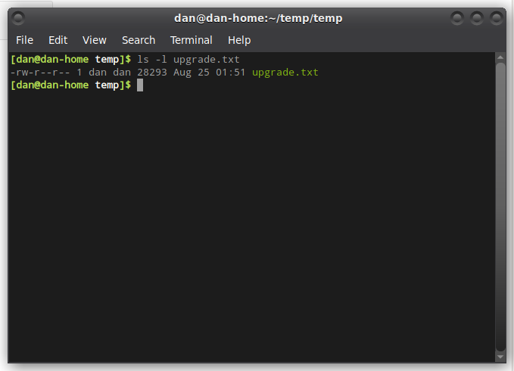
As you can see, it is owned by user ‘dan’ who is a member of group ‘dan’. If we wanted to change the owner of the file to ‘root’, we could do that by using the command ‘sudo chown root:root upgrade.txt’. The reason we need the ‘sudo’ is so that we can utilize the root user. Any time we are doing something which involves a user other than who we are, we will be required to use ‘sudo’

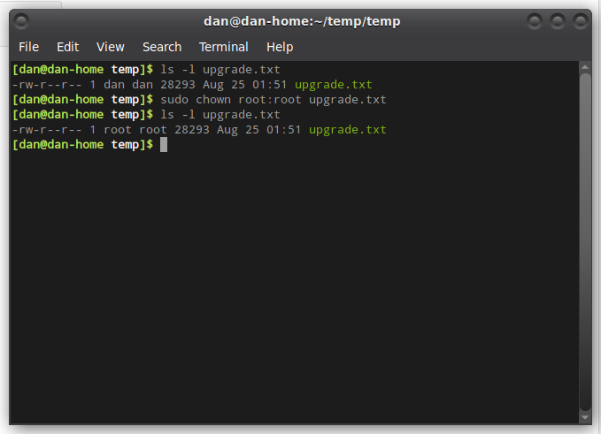
You will notice that we have changed both the owner of the file, and the group to ‘root’. In order to change it back we would use the command ‘sudo chown dan:dan upgrade.txt’

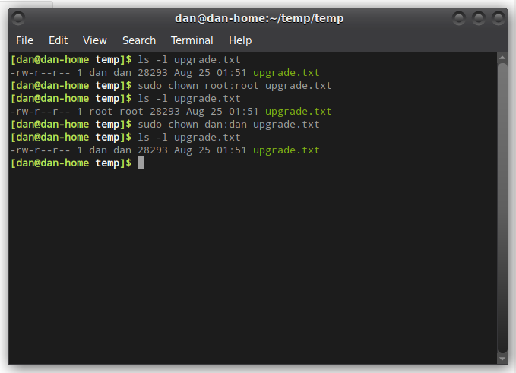
Then the file is back to user ‘dan’ and group ‘dan’.

Now, if you just wanted to change the group owner only, there is a command for that as well.

chgrp

The syntax for ‘chgrp’ is almost identical to that of ‘chown’. ‘sudo chgrp group filename’

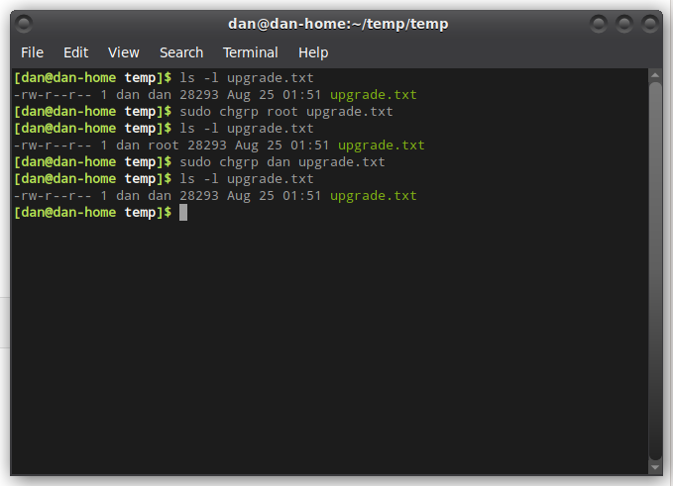
In this screenshot, you can see that I changed just the group from ‘dan’ to ‘root’, and then changed it back to ‘dan’.

Here are some random tips that might help you out.

- The file /etc/group contains all of the groups defined on your system.
- You can use the command ‘groups’ to list all of the groups you are a member of
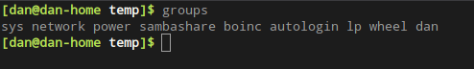
- You can use the command ‘newgrp’ to work as a member of a group other than your default
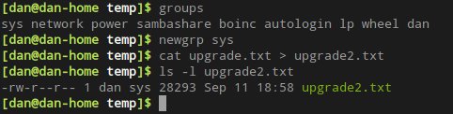
- You cannot have 2 groups owning the same file.
- You do not have nested groups in Linux. One group cannot be a sub-groups of another
- x- eXecuting a directory meansbeing allowed to “enter” a directory and gain access

I hope this gives you a better understanding of permissions and how to change them. This is an area that most new Linux users struggle with, including me.

